WordPress Tasks for Week 03 Updated: 16-Jul-2017
- You should be working on surname1.it5a.com.au or similar on GOHOSTING. Make sure you are not working on jupiter.
- Perform all Updates of your plugins and themes, and even WordPress itself, when a new version comes. Do this every week. Not doing updates exposes your site (and our server) to potential security risks.
- Make sure you have fully completed all parts of last week's worksheet, in particular:
  - Go to Settings | Reading and make sure you hide this site from Google and other search engines. You would not do this in a real live Website of course. Why is it important to do this here?
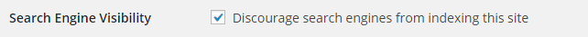 _______________________________________________
  - Make sure you have activated the OnePress theme. It can be found under Themes| Add New
  - Make sure any headings marked as <h2> in the text are actually formatted with the Heading 2 style etc
  - Make sure you have installed the plugin Easy Google Fonts and changed the Font Family for <p>, <h1>, <h2> and <h3> to a sans serif font, such as Arial or Verdana, via Appearance | Customize | Typography
  - Activate Akismet, which is already installed by default. This plugin is essential to block spam. You'll need to sign up for an API key from WordPress.com. This is free of charge if you move the slider on the site.
- Upload the image of Cimaja Homestay with the motorbike in front of the hotel (from the .zip file on Blackboard) to the Media Library. Add a Large version of this image at the position indicated in the Word file. Centre it as per page 3.
- Add a Caption to this image in the Media Library as shown on page 3 below. Change the Alt Text and Image Title properties also. These are important for accessibility purposes. You can use similar wording for each. This can be done in the Media Library. These are also important for SEO purposes. What is SEO?
______________________________________________________________________________________________
- Add the "More" tag immediately after the first paragraph in the Cimaja Homestay post and immediately after the first paragraph in the Villa Marasai post. Check the post to see how it looks. In some themes these are added automatically
______________________________________________________________________________________________
- Find an example of a masonry style of theme, such as used on Pinterest. ________________ What do they look like?
- Go to Appearance | Widgets area and a Calendar widget at the very bottom of the sidebar.
Watch video 21.4 from http://www.wrox.com/WileyCDA/Section/id-825053.html These are all really great videos!
- Add, remove and move widgets until your sidebar looks like http://lewis1.dipit.com.au You should have widgets for Search, Categories, Recent Posts and Calendar only and in that order. Please demonstrate this to your teacher next week.
- Add the post for Harry's Ocean House, Pacitan using the Word file available on Blackboard.
- In the Harry's Ocean House post select the paragraph ("Pacitan is a gem …) and format it as a Blockquote. (Use the Blockquote button.) Also check the bulleted points and headings are as per the Word file.
- Add any headings plus the More tags, Categories and Tags etc as indicated in red in the Word files. There is a screenshot of the Categories and Tags below (on page 3). Please demonstrate these to your teacher next week.
- Trash the default Sample Page. Add a New Page called Our Staff and add the text for this page from the Word file.
- Try adding Medium size versions of the images of the staff members Kate Smith and Sandra Pereira at the very beginning of the relevant paragraph, as per the Word file. Add the Captions, Alt Text etc. Edit your post so that the image floats to the right, as per http://lewis1.dipit.com.au
- Change from the Default Template to the Full Width template (Not all themes have this) for the Our Staff page (only). No sidebar or widgets should now be visible. Does the text occupy 100% of the width of the page or not? _____
- Ensure that comments cannot be made on the Our Staff page.
You may first need to check  Discussion under Screen Options at the top. Next you need to uncheck the Discussion setting ✓ Allow comments at the bottom of the Page. Do this for all future Pages also (but not for Posts).
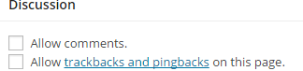
- Check that all links open up in a new tab. Why is this important? _________________________________________
Exploring Photoshop (Do this before you add the 12 images in the three folders to the Media Library)
- Although WordPress "crunches" all images added to the Media Library and produces three copies of different sizes, Web professionals often use Photoshop to pre-process images. You still need to choose which image size you want to add.
If you do want to crop images (You won't in our case) here's a good tute on cropping with Photoshop: http://www.photoshopessentials.com/photo-editing/crop-images/
Select the 4 images for Cimaja Homestay (all landscape), then the 4 images for Villa Marasai (all landscape) and finally the 4 images for Harry's Ocean House (all landscape).
Photoshop has a better algorithm and thus produces better images than other software
Pre-process them in Photoshop (available on mydesktop) as follows:
  - The image of the volcano needs to be lightened - HINT: Image | Adjustments | Brightness
  - Landscape images should probably be around 800 x 600 pixels - HINT: Image | Image Size or File | Export As
  - All images probably should be less than 200 kB - HINT: File | Export As (In old versions use 'Save for Web')
Please watch the following video: https://www.youtube.com/watch?v=QSyb_6NRDeI&feature=youtu.be
NOTE: Photoshop Navigator (at the top RHS) will allow you to view the image at different sizes eg. 100% or use Ctrl +
- Add image galleries at the positions indicated in the Cimaja Homestay, Villa Marasai and Harry's Ocean House (all landscape pics) Posts. You can use Photo Gallery by Supsystic, which is free and produces professional results quickly.
The 12 images you first re-sized and/or Photoshopped should then be added to the Media Library. Add Alt text and a Description for each image (They can be the same), but probably not a Caption.
Fixed layout works fine, but you can experiment. One client requirement is that the images be in two columns. You can try 360 x 280 px (for landscape). Probably increase the Images distance to 20 px and Image radius to 10 px.
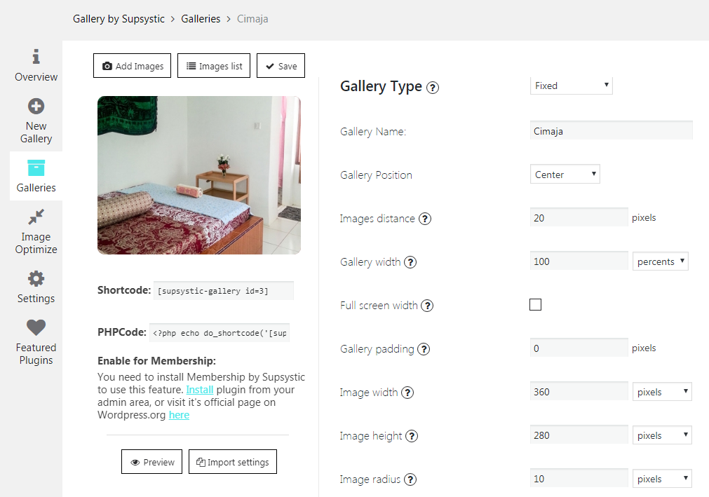
Alternatively you can try other gallery plugins such as NextGen Gallery, Foo Gallery etc. However the gallery must look professional, as per the sample Website.
Once you have installed and activated Photo Gallery by Supsystic click on New gallery and type in a Gallery Name such as 'Cimaja' and click on Save.
Note the Shortcode which needs to be pasted into your Post (or Page) at the appropriate spot.
First click on Add Images of course though. Probably choose Import from WordPress Media Library
- The following step is essential and will be explained to you by your teacher in class. If your text and any images are not separated by at least one blank line, you cannot simply press Enter or add a <br> tag. Add &nbsp; in Text mode
- Add the YouTube video to the Villa Marasai post (The URL is in a text file) at the position indicated in the Word file. There are a few ways to do this. Try them and make sure you test your site on a phone.
- METHOD 1: Paste the URL straight into the page (This can be done in Visual mode, not Text mode.) - not centred!
- METHOD 2: Paste the embed code into the page, again in Text view. This code is from right clicking on the video.
<p style="text-align: center;"> <iframe src="https://www.youtube.com/embed/ULFf84MvI4U" width="560" height="315" frameborder="0" allowfullscreen="allowfullscreen"></iframe> </p>
- METHOD 3: Install a plugin such as DW FitVids, useful if your video is not responsive eg. to a phone
Three similar methods can be used to add Google Maps also. Plugins are not really required in most cases however
- Add a PDF document (Guide to Surfing in West Java) immediately before the words "There are some amazing caves at Goa Lalay …" Click on Add Media etc. Clicking on the link should download the PDF file.
Download your Guide to Surfing West Java (PDF) Here (Insert a link)
- This may take a while. Create a new an attractive header image perhaps around 300 x 100 pixels. It should consist of a suitable logo (or a photo) plus the words "Island Travel" in a fancy font.
You can find free images that do not require attribution from http://pixabay.com There are hundreds of images of Indonesia or Thailand there, including some excellent sunset shots, which might be suitable for your header.
You can use Photoshop, or any other software. The editor at https://pixlr.com is excellent.
You may prefer to create a logo using a logo-creation Website, or any other method. Try http://canva.com which is used by WordPress professionals and is very simple. If you upload your own image, this is free.
- Add the Island Travel header image to the theme. Simply go to Appearance | Customize in the Dashboard. Also remove the Site Title and Tagline either under Customize or by going to Settings.
You should now have a total of 3 Posts and 1 Page. Please check the Website indicated by your teacher
- This may take a while. Create at least one of the plugins (Thanks for Reading, a modified version of Catify or the Contact Form) from the Websites given on page 2 of the Week 2 worksheet, and demonstrate it. For bonus marks try to customise your plugin.
Feature | Details | Self Check
New header image added
Sans-serif fonts used | Use Easy Google Fonts
3 Posts added & formatted | Cimaja Homestay | Villa Marasai | Harry's …..
Large pic added with Caption etc. | In Cimaja Homestay
More tags added | In all three posts
Widgets added & removed | As per lewis1.dipit.com.au
3rd Post added & formatted | Harry's Ocean House
Blockquote added
Page completed
Staff photos look professional | eg. floated right or similar
Sidebar removed | Page template changed
Comments disabled
3 Image galleries added | In all three Posts
Images are correct & landscape | Cimaja, Villa, Harry's: all landscape
Galleries look professional | eg. pics are not too small, or next to text
Captions removed from all pics | Via the Media Library
2 videos added | In Villa & Harry's posts
Videos are responsive | Test on your phone
1 PDF (Surfing West Java) added | In Cimaja Homestay
Attractive new header with logo

Categories & Tags for our Posts
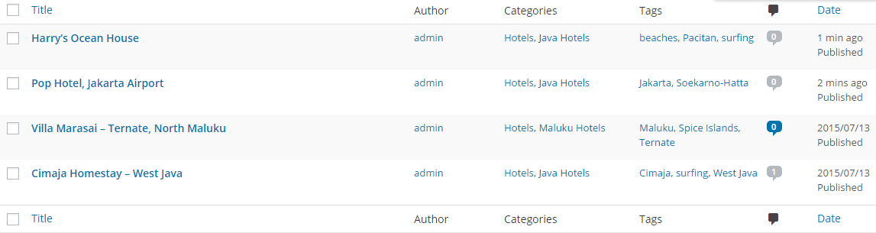
[Grab your reader’s attention with a great quote from the document or use this space to emphasize a key point. To place this text box anywhere on the page, just drag it.]

Show this to your teacher. This is a required demonstration (a very small part of your assessment)

Image Properties
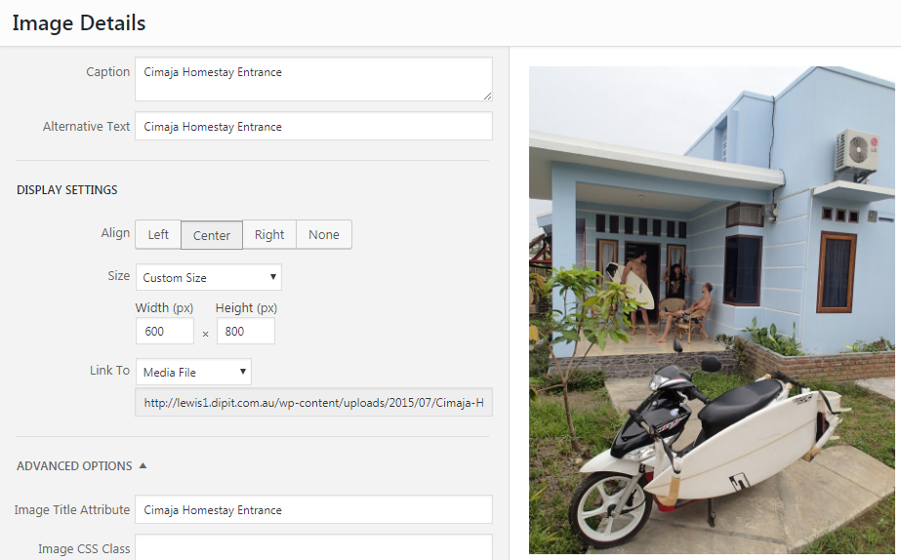
More Tags
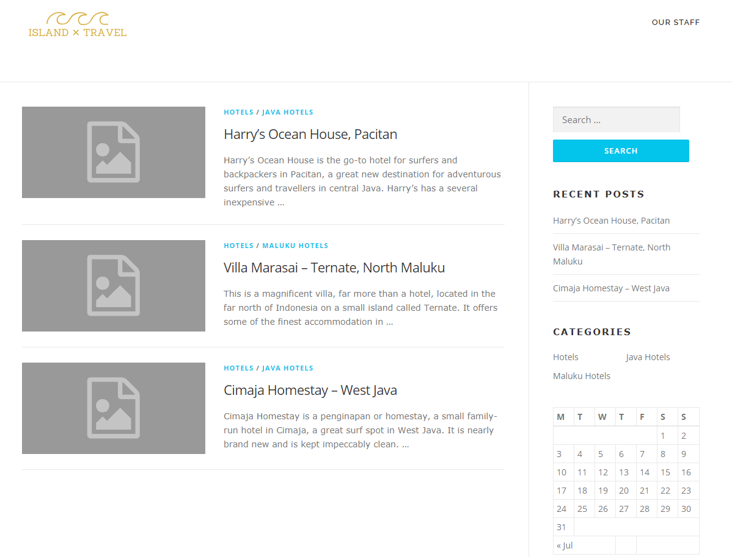

There should of course be one more post above these (Harry's Ocean House)

Using Easy Google Fonts
